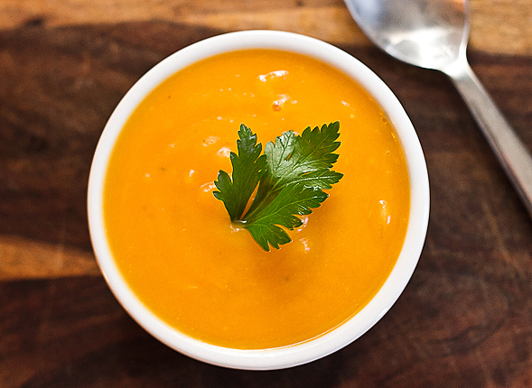

Winter Squash Soup

4 SERVINGS
Nutrition Facts per Serving:
Calories: 236 Protein (g): 7
Fat (g): 16.5 Carbohydrate (g): 16

Ingredients:
2 tablespoons unsalted butter
1 tablespoon good olive oil
2 cups chopped yellow onions (2 onions)
1 (15 - ounce) can pumpkin puree
1 1/2 pounds butternut squash, peeled and cut in chunks
3 cups homemade chicken stock or canned broth
2 teaspoons kosher salt
1/2 teaspoon freshly ground black pepper
1 cup low fat half and half
Grated Gruyere (optional)
Instructions:

- Heat the butter and oil in a soup pot. Add the onions and cook over medium-low heat for 10 minutes or until translucent.

- Add the pumpkin puree, butternut squash, chicken stock, salt and pepper. Cover and simmer over medium heat for 20 minutes, until the butternut squash is very tender.

- Process the mixture through a food processor or blender. Return to the pot, add the half and half and heat slowly. Serve hot with gruyere if desired.

