Swiss Chard with Shallots
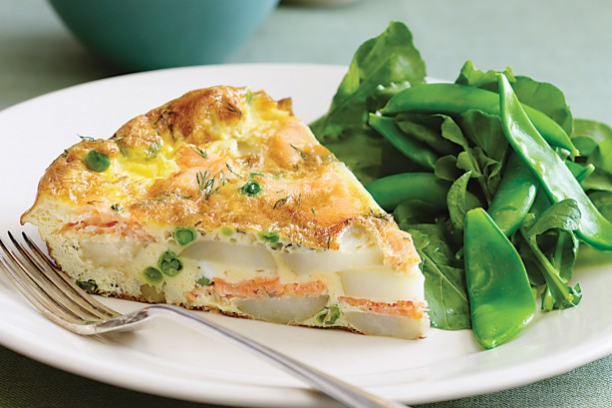
4 SERVINGS
Nutrition Facts per Serving:
Calories: 105 Protein (g): 8
Fat (g): 11 Carbohydrate (g): 10

Ingredients:
1 ¼ pounds Swiss chard
1/3 cup slivered almonds
2 tbsp olive oil
2 large shallots, thinly sliced
1 tbsp or more cider vinegar
Dried cherries (optional)
Salt

Instructions:

- Prepare the Swiss chard by stripping the leaves from stems. Slice the stems on a diagonal about ½ inch thick. Chop leaves into large pieces.
- Toast almonds in a large skillet over medium heat without oil, shaking the pan occasionally, until almonds are lightly browned – about 3-4 minutes. Set aside.
- Heat oil in the same skillet and increase heat to medium. Add shallots and chard stems stirring frequently until soft and browned, about 6 minutes. If skillet begins to brown too quickly, add 2tbsp water.
- Add a handful of chard leaves and a little salt, stirring until they wilt. Continue to add leaves seasoning lightly until all leaves are wilted.
- Transfer from heat and drizzle with vinegar and some additional olive oil. Top with almonds and serve.
- Sprinkle with diced dried cherries

