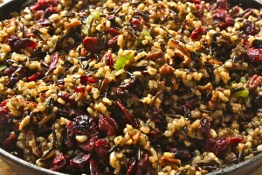
Wild Rice Stuffing with Dried Cherries and Toasted Pecans

12 SERVINGS
Nutrition Facts per Serving:
Calories: 266 Protein (g): 6
Fat (g): 9 Carbohydrate (g): 40

Ingredients:
2 cups | Leek, thinly sliced
1 tbsp. | Fresh thyme, chopped
1 tsp. | Kosher salt, divided
3 cups | Water
2 cups | Fat-free, lower sodium chicken or vegetable broth
1 cup | Uncooked wild rice
2 cups | Uncooked long-grain brown rice
½ cup | Turnip, peeled and finely chopped
1/3 cup | Celery, finely chopped
1/3 cup | Carrot, finely chopped
2/3 cup | Toasted pecans, chopped
½ cup | Dried sweet cherries, chopped
2 | Green onions, thinly sliced
¼ cup | Butter, divided

Directions:
- Heat 2 tablespoons butter in a large saucepan over medium heat; swirl to coat.
- Add leek, thyme, and ½ tsp. salt. Sauté 8 minutes, stirring occasionally.
- Add 3 cups water, chicken broth, and wild rice; cover. Increase heat to high; bring to a boil.
- Reduce heat, and simmer 30 minutes.
- Stir in brown rice; cover and simmer 30 minutes. Remove from heat.
- Preheat oven to 400°.
- Heat remaining 2 tablespoons butter over high heat in a large skillet; swirl to coat.
- Add turnip, celery, carrot, and remaining ½ teaspoon salt; sauté 1 minute. Reduce heat to medium; cook 4 minutes, stirring occasionally. Remove from heat.
- Combine rice mixture, turnip mixture, pecans, cherries, and onions in a large bowl. Spoon stuffing into a 13 x 9-inch glass or ceramic baking dish. Cover with foil; bake at 400° for 20 minutes or until liquid is absorbed. Let stand 5 minutes before serving.

