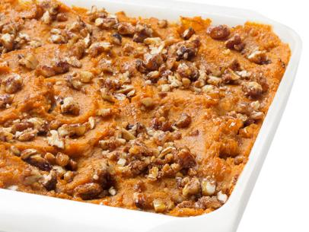
Sweet Potato Pecan Casserole

8 SERVINGS
Nutrition Facts per Serving:
Calories: 160 Protein (g): 3
Fat (g): 4 Carbohydrate (g): 31

Ingredients:
3 ½ lbs. | Sweet potatoes (about 5 medium), peeled, cut into 1-in. chunks
1/3 cup | Honey
1 | Large egg
1 tsp. | Ground cinnamon
1/8 tsp. | Ground ginger
¼ tsp. | Ground nutmeg
1 tbsp. | Packed dark brown sugar
1/3 cup | Pecans, finely chopped
 | Kosher salt to taste

Instructions:
- Preheat oven to 350°F. Grease an 8-in. square baking sheet with cooking spray.
- Bring a few inches of water to a boil in a large pot lined with a steamer basket.
- Put the sweet potatoes in the basket, cover and steam until tender, 20-25 minutes.
- Transfer potatoes to a bowl and let cool slightly. Add honey, egg, ½ tsp. cinnamon, nutmeg, ginger, and ½ tsp. salt. Beat with an electric mixer until smooth.
- Spread the potato mixture in the prepared dish.
- Mix the brown sugar, pecans, and remaining ½ tsp. cinnamon in a bowl. Sprinkle over the potatoes.
- Bake until hot and beginning to brown around the edges, 40-45 minutes.

