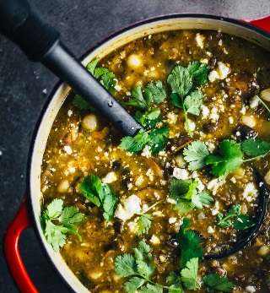
Mushroom Poblano Posole Verde

8 SERVINGS
Nutrition Facts per Serving:
Calories: 185 Protein (g): 5
Fat (g): 5 Carbohydrate (g): 3

Ingredients:
2 tbsp. | Olive oil
½ | Yellow onion, minced
2 | Poblano peppers, seeds removed, minced
½ | Jalapeno pepper, seeds removed, minced
16 oz. | Fresh sliced baby bella mushrooms
1 tsp. | Southwest seasoning
24 oz. | Salsa verde
1 cup | Water
4-5 cups | Vegetable broth
¾ cup | Uncooked bulgur
2 | 14-oz. cans white hominy
1 ½ tsp | Salt
 | Optional: cilantro, lime juice, cotija cheese for serving
Instructions:
- Heat the olive oil over medium high heat. Add the onions and sauté for 1-2 minutes.
- Add the peppers and mushrooms. Sauté for 10-15 minutes or until the mushrooms are cooked down to about half their volume and are deep brown.
- Add the seasoning, salsa verde, water, broth, bulgur, and hominy. Simmer about 15 minutes or until the bulgur is soft.
- Serve with cilantro, a squeeze of lime juice, and cotija cheese.

Note: you may want to add more broth or water to the leftovers. The soup will thicken as the bulgur continues to soak up moisture.

