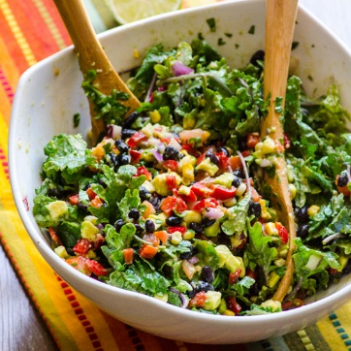
Healthy Creamy Mexican Kale Salad
6 SERVINGS
Nutrition Facts per Serving:
Calories:242 Protein (g): 9.3
Fat (g): 11.2 Carbohydrate (g): 31.8

Ingredients:
Salad:
4 cups Kale, coarsely chopped
14 oz Canned black beans, drained and rinsed
1cup Corn kernels
2 Bell peppers (any color), finely chopped
1 Large avocado, finely chopped
1 Tomato, finely chopped
½ cup Red onion, finely chopped
½ cup Cilantro, finely chopped
1tbsp Jalapeno pepper, de-seeded and minced
Dressing:
½ Avocado
1/2cup Warm water
2tbsp Lime juice
1tsp Cumin
¾ tsp Salt
½ tsp Black pepper
Instructions:
Salad:
- Chop kale, peppers, avocado, tomato, onion and cilantro. Mince jalapeno.
- Add all ingredients into a large mixing bowl
Dressing:
- Add all dressing ingredients to blender or food processor.
- Blend until smooth.
- Pour over salad, toss, and serve.

