Rosemary Potato Frittata
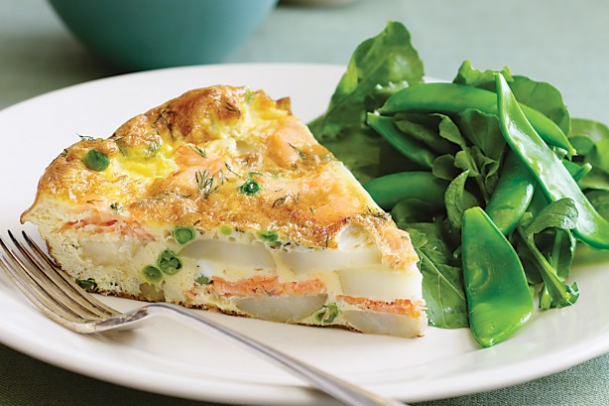
4 SERVINGS
Nutrition Facts per Serving:
Calories: 409 Protein (g): 21
Fat (g): 19 Carbohydrate (g): 24

Ingredients:
¼ cup olive oil
1 large clove of garlic, crushed
1 pound baby potatoes
1 small onion
3-4 sprigs of rosemary, chopped
12 eggs, beaten
½ cup low fat milk
½ cup Parmesan cheese
Salt and freshly ground pepper
Instructions:

- Heat oven to 450 degrees. Heat the olive oil in a medium skillet over medium-low heat with crushed garlic.

- Add potatoes and onions to the skillet and season with rosemary, salt, and pepper to taste. Raise heat slightly and cook 6-7 minutes. Turn the potato/onion mixture over and cook for 5 minutes more.

- In a large bowl, whisk eggs and milk together. Add egg mixture to the skilled and move them around and under the potatoes to settle them.

- Transfer the skillet to the oven and bake until golden on top, 10-12 minutes. Scatter the cheese on top, turn the oven off and let sit for another few minutes. Remove from the oven and serve.

