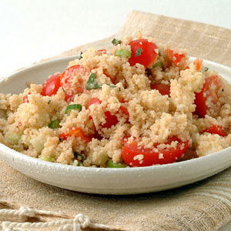
Mediterranean Couscous

4 SERVINGS (3/4 cup per serving)
Nutrition Facts per Serving:
Calories: 230 Protein (g): 8
Fat (g): 4 Carbohydrate (g): 42

Ingredients:
1 cup | Whole wheat couscous
1 cup | Chicken or vegetable broth
1 | Red bell pepper, diced
1 | Zucchini, diced
½ | Yellow onion, diced
2 | Garlic cloves, minced
½ tbsp. | Olive oil
1 tsp. | Garlic powder
1 tsp. | Paprika
½ tsp. | Thyme
½ tsp. | Salt
½ tsp. | White pepper
1 tbsp. | Freshly squeezed lemon juice
Instructions:
- Preheat oven to 350°F.
- Cook couscous according to package directions, using broth rather than water.
- Heat olive oil in a frying pan. Add and sauté onion, bell pepper, zucchini, and garlic for 5 minutes.
- Mix all vegetables and spices together except the lemon juice. Place in a casserole dish and bake for 30 minutes or until slightly browned.
- Sprinkle with lemon juice and serve.

