Healthy Man Wings
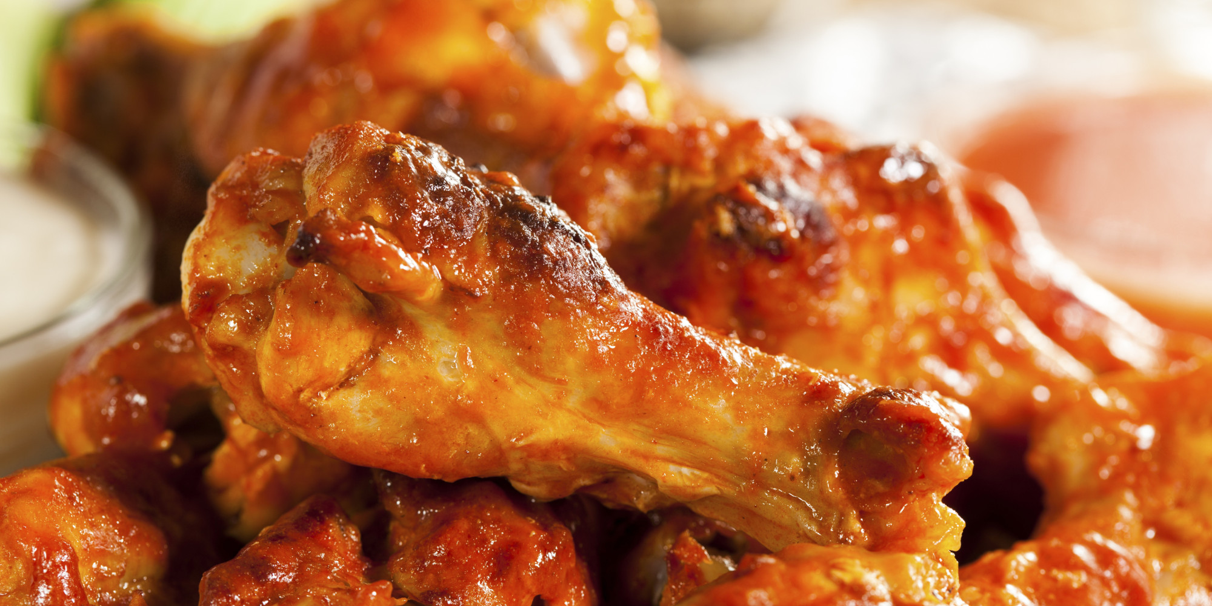

4 SERVINGS
Nutrition Facts per Serving:
Calories: 305 Protein (g): 35
Fat (g): 10 Carbohydrate (g): 19

Ingredients:
2 lbs chicken wings and drumsticks
2 tbsp honey
4 tbsp Dijon mustard
2 tbsp turmeric
1 tbsp lemon juice

Instructions:
- Rinse and pat dry chicken, then trim off visible fat.
- Place chicken in a large pot. Fill pot with cold water until chicken is covered by two inches. Bring water to a boil and boil for 10 minutes.
- While chicken is boiling, put remaining ingredients in a large Ziploc bag and shake to mix.
- Set broiler to high. Once chicken is done, remove from water and add to Ziploc bag.
- Shake until all wings are fully covered with marinade. Place chicken on a baking sheet and broil for 6 minutes on each side until skin starts to crisp.

