Stuffed Man Peppers
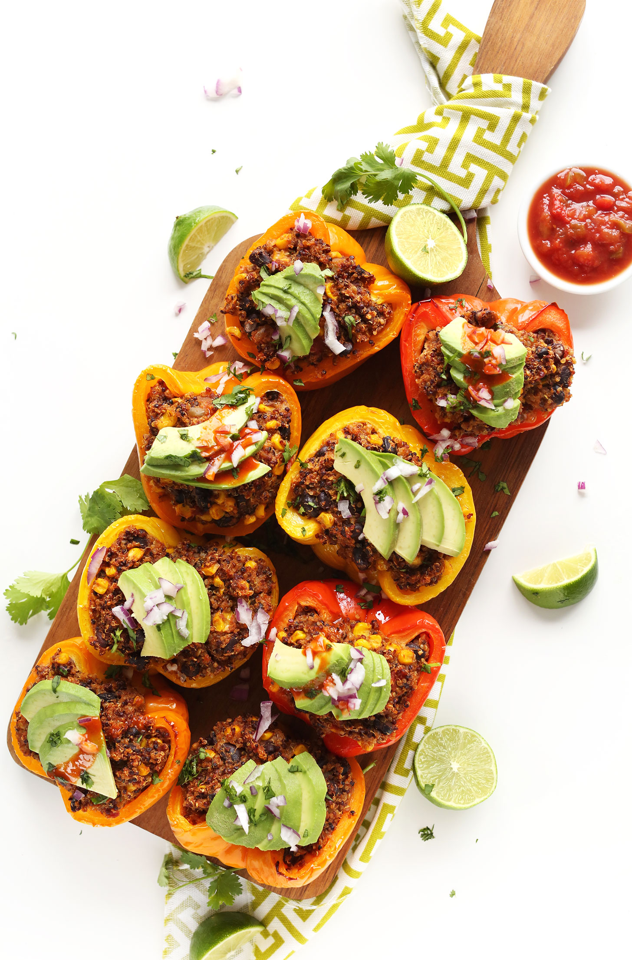

4 SERVINGS
Nutrition Facts per Serving:
Calories: 160 Protein (g): 5
Fat (g): 6.5 Carbohydrate (g): 22

Ingredients:
EPPERS
1 cup quinoa, rinsed and drained
2 cups vegetable broth
4 large red bell peppers halved, seeds removed
1/2 cup salsa, plus more for serving
1 Tbsp nutritional yeast
2 tsp cumin powder
1 1/2 tsp chili powder
1 1/2 tsp garlic powder
1 15-ounce can black beans, drained
1 cup whole kernel corn, drained
TOPPINGS optional
1 ripe avocado, sliced
Fresh lime juice
Hot sauce
Cilantro, chopped
Diced red onion
Directions:
- Add quinoa and vegetable stock to a saucepan and bring to a boil over high heat. Once boiling, reduce heat, cover, and simmer until all liquid is absorbed and quinoa is fluffy - about 20 minutes.
- Preheat oven to 375 degrees F and lightly grease a 9x13 baking dish or rimmed baking sheet. Brush halved peppers with olive oil.
- Add cooked quinoa to a large mixing bowl and add remaining ingredients - salsa through corn. Mix, then generously stuff halved peppers with quinoa mixture until all peppers are full, then cover the dish with foil.
- Bake for 20 minutes covered, then remove foil, increase heat to 400 degrees F, and bake for another 15-20 minutes, or until peppers are soft and slightly golden brown. For softer peppers, bake 5-10 minutes more. Serve with desired toppings or as is.

