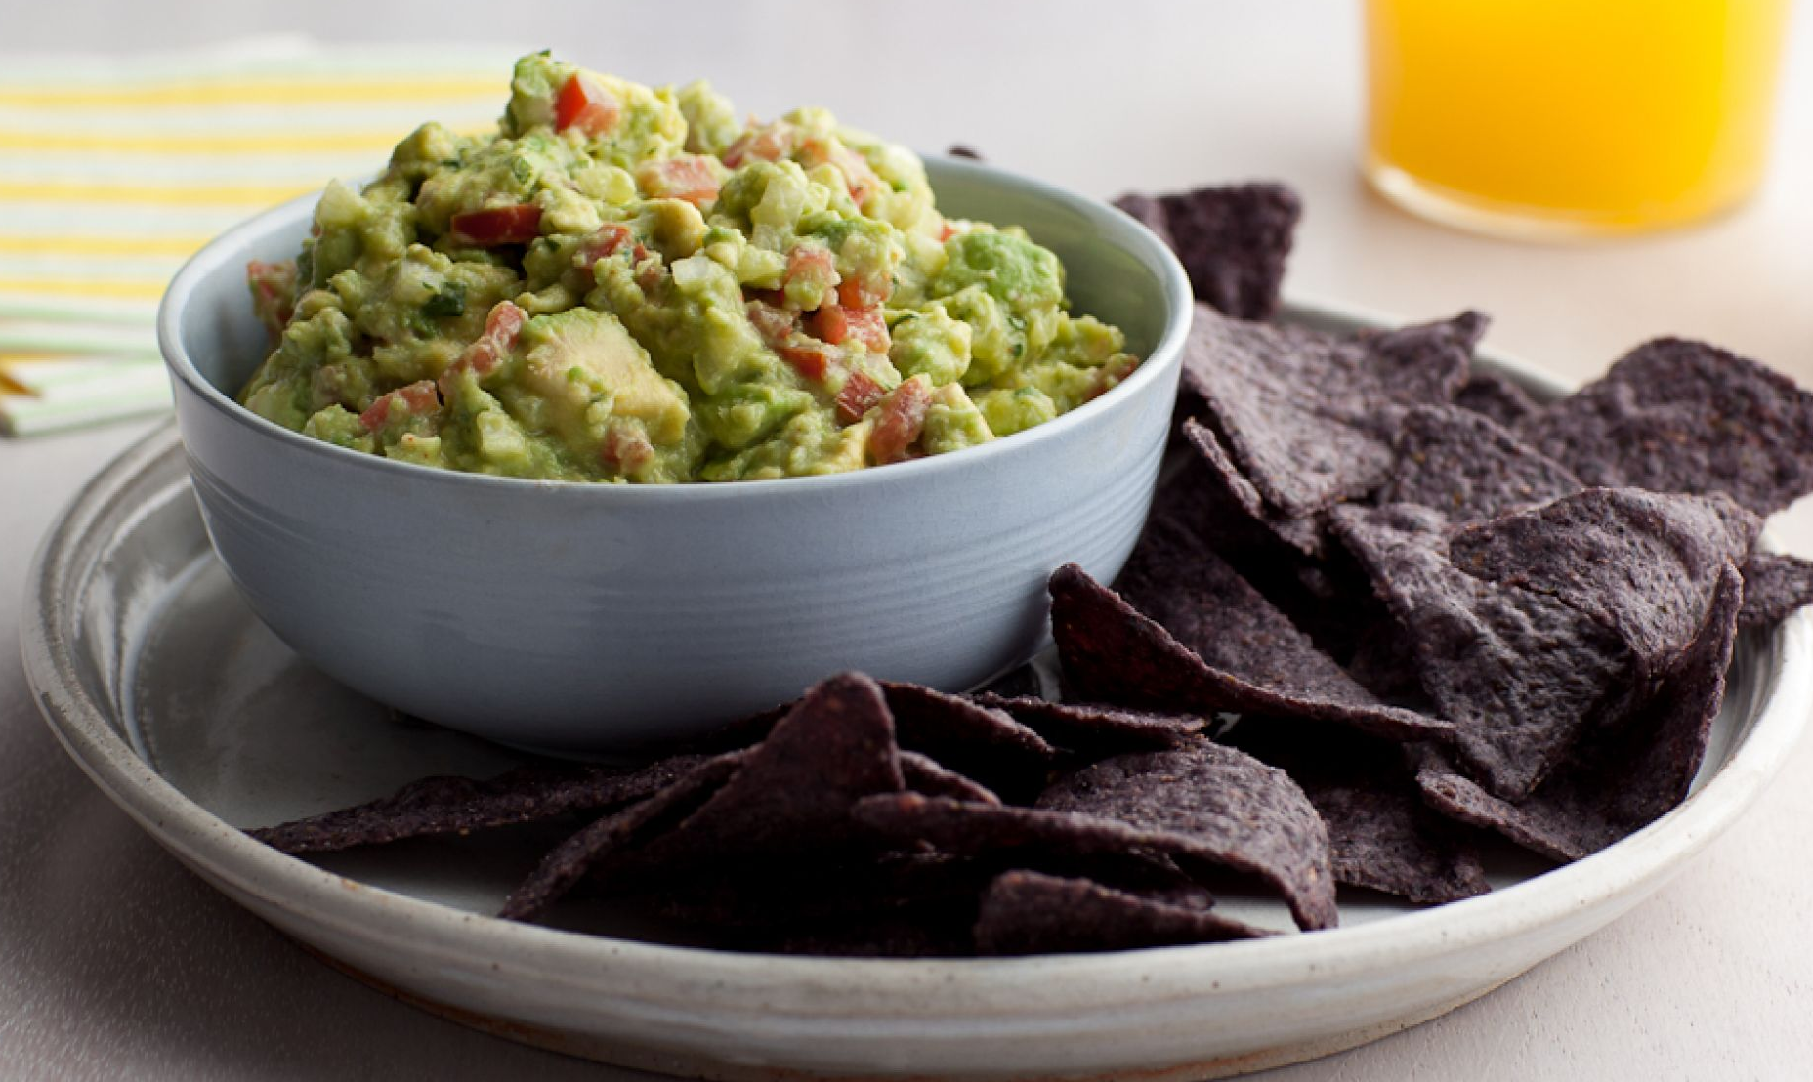

Guacamole

6-8 SERVINGS
Nutrition Facts per Serving:
Calories: 170-225 Protein (g): 2-3
Fat (g): 15 Carbohydrate (g): 12-15

Ingredients:
4 ripe avocados
3 tablespoons freshly squeezed lime juice
8 dashes of tobacco
1 red onion diced small
1 large clove garlic, minced
1 teaspoon salt
1 teaspoon ground pepper
1 medium tomato, seeded and diced

Instructions:
- Cut the avocados in half, remove the pits, and scoop the flesh out of their shells into a large bowl. Immediately add lime juice, hot sauce, onion, garlic, salt, and pepper and toss well.
- Using a sharp knife, slice through the avocados in the bowl until they are finely diced. Add tomatoes.
- Mix well and taste for salt and pepper.

