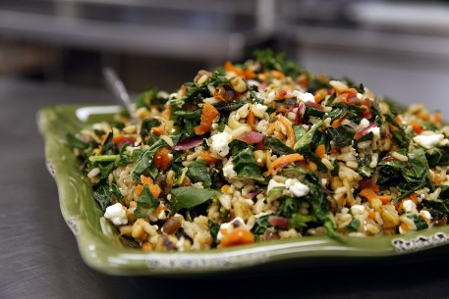
Greens with Carrots, Feta Cheese, and Brown Rice

4 SERVINGS (1.5 cups per serving)
Nutrition Facts per Serving:
Calories: 307 Protein (g): 11
Fat (g): 10 Carbohydrate (g): 45

Ingredients:
2 | Carrots, shredded
2 bunches | Dark leafy greens (kale, collard greens, or Swiss chard), tough stems removed, leaves very thinly sliced
¼ cup | Water
½ | Red onion, finely chopped
1 cup | Feta cheese, crumbled
1 cup | Brown rice, dry
 | Salt and black pepper, to taste
Instructions:
- Cook rice according to package directions.
- Put carrots, greens, onions, water, salt, and pepper into a large, deep skillet and toss well.
- Cover and cook over medium heat, tossing once or twice, until greens are wilted and tender, 10 to 15 minutes.
- Toss with feta cheese and spoon over brown rice.

