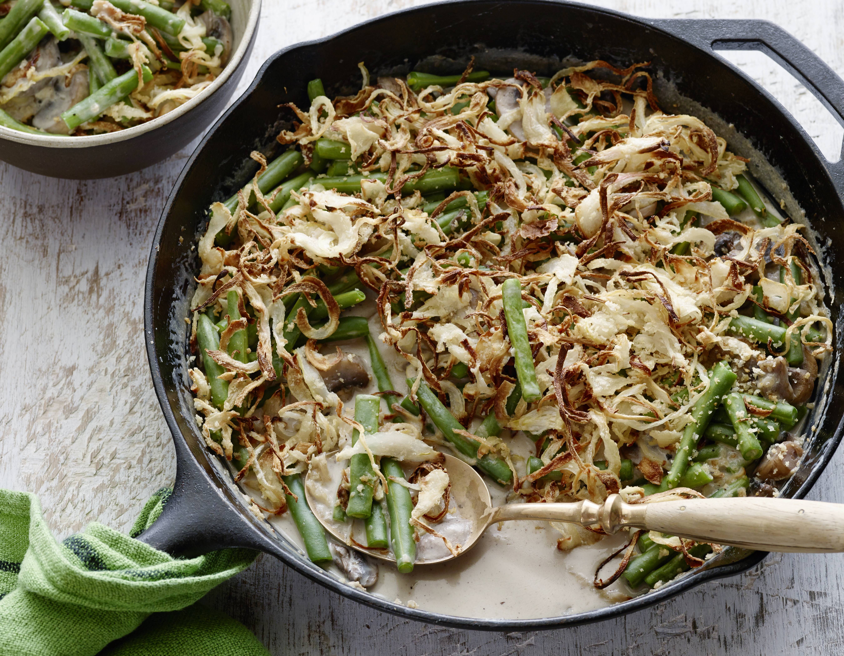
Green Bean Casserole

6 SERVINGS
Nutrition Facts per Serving:
Calories: 155 Protein (g): 13
Fat (g): 12.5 Carbohydrate (g): 24

Ingredients:
Nonstick cooking spray, for greasing
5 cups sliced green beans
4 1/4 cups low-sodium chicken broth
1 cup panko breadcrumbs
1 cup grated Parmesan
1 tablespoon plus 2 teaspoons canola oil
1 1/2 cups diced onions
2 cups sliced baby bella mushrooms
2 tablespoons cornstarch
1/2 cup reduced-fat sour cream
1/2 teaspoon House Seasoning, recipe follows
1/2 teaspoon salt
House Seasoning
½ tsp kosher salt
½ tsp garlic powder
½ tsp cup black pepper

Instructions:
- Preheat the oven to 350 degrees. Spray a baking dish with nonstick spray.
- Boil the green beans in broth for 20 minutes, then drain, reserving 1 1/2 cups of broth.
- Meanwhile, mix together the breadcrumbs, Parmesan and 2 teaspoons of the oil in a small bowl. Set aside.
- Heat the remaining 1 tablespoon oil in a large skillet over medium heat. Saute the onions until translucent, 2 to 3 minutes, and then add the mushrooms and continue to cook for 3 to 4 minutes longer. Remove from the heat.
- Pour reserved chicken broth back into the pot the green beans were boiled in and bring to a boil. Add the green beans to the skillet with mushrooms and onions.
- While that is coming to a boil, combine the cornstarch and 1/4 cup water in a small bowl to make a slurry. Slowly pour the slurry into the boiling broth, whisking constantly as it thickens, about 2 minutes. Pour the thickened mixture over the green beans and add the sour cream, House Seasoning and salt. Stir well.
- Pour into the baking dish and sprinkle with the panko and cheese mixture. Bake until the casserole is hot, about 10 minutes, and then broil until the breadcrumb topping is slightly browned, 1 to 2 minutes.

