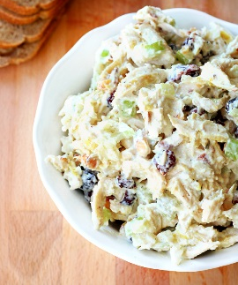
Greek Yogurt Chicken Salad

2 SERVINGS
Nutrition Facts per Serving:
Calories: 235 Protein (g): 29
Fat (g): 8 Carbohydrate (g): 1

Ingredients:
1 | Chicken breast, cooked, chilled, and shredded
1 | Small apple, diced
¼ cup | Roasted almonds, chopped
2 | Green onions, sliced
¼ cup | Plain Greek yogurt
1 tbsp. | Mustard
 | Salt and pepper to taste
Instructions:
- Mix all ingredients together.
- Serve on top of mixed greens for a salad lunch, on whole grain toast for a hearty sandwich, or on cucumber slices for a snack or hors d’oeuvre.

