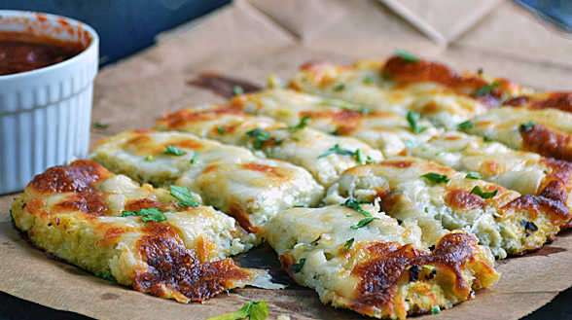

Cauliflower Breadsticks

6 SERVINGS
Nutrition Facts per Serving:
Calories: 126 Protein (g): 10
Fat (g): 5.5 Carbohydrate (g): 9

Ingredients:
1 head raw cauliflower, riced
1/2 cup shredded Low Fat Mozzarella Cheese
1/2 cup shaved Parmesan Cheese
1 large egg
1/2 tablespoon freshly minced garlic
1/2 tablespoon freshly chopped basil
1/2 tablespoon freshly chopped Italian flat-leaf parsley
1 teaspoon salt
1/2 teaspoon ground black pepper
1/2 cup shredded Mozzarella Cheese

Instructions:
- Preheat oven to 425 degrees and line a baking sheet with parchment paper.
- Break cauliflower into florets. Add to food processor and pulse until it has the texture of rice.
- In a large bowl, mix the riced cauliflower, ½ cup Mozzarella cheese, ½ cup Parmesan cheese, 1 egg, ½ tbsp. fresh garlic, ½ tbsp. fresh basil, ½ tbsp. fresh parsley, 1 tsp salt and ½ tsp black pepper until combined and holds together. Place the mixture onto the lined baking sheet and spread out until roughly ¼ inch thick.
- Bake in the preheated oven for 10-12 minutes. Remove from oven and top with remaining Mozzarella cheese and return to oven to continue baking until the cheese is melted and starting to brown. Cool about 10 minutes and cut into breadsticks. Garnish with herbs and serve!

