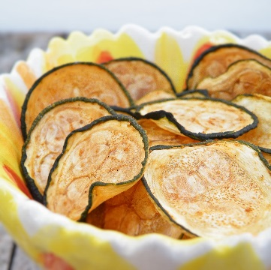
Baked Zucchini Chips

4-6 SERVINGS (1 cups per serving)
Nutrition Facts per Serving:
Calories: 35 Protein (g): 1
Fat (g): 0 Carbohydrate (g): 6

Ingredients:
3 | Medium zucchini
2 ½ tbsp. | Flour
½ tsp. | Smoked paprika
½ tsp. | Garlic powder
 | Salt, to taste
 | Cooking spray
Instructions:
- Preheat oven to 350°F. Coat baking sheet with cooking spray.
- Cut zucchini into small circle chips about the width of a nickel or quarter.
- Mix the paprika, garlic powder, flour and salt into a mixing bowl and toss the zucchini until it is covered in the mixture.
- Lay the zucchini onto the baking sheet. Bake for 30-40 minutes, flipping the zucchini chips over about every ten minutes.
- Enjoy fresh and crunchy out of the oven.

