Oatmeal Stuffed Baked Apples
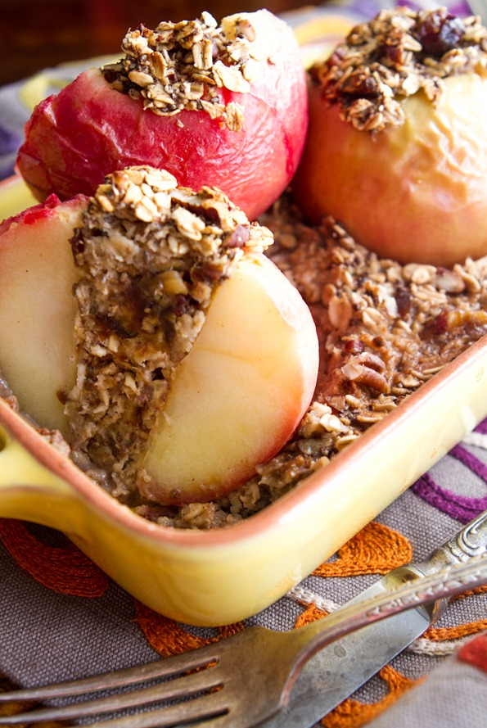
4-8 SERVINGS
Nutrition Facts per Serving:
Calories: 105 Protein (g): 1.5
Fat (g): 3 Carbohydrate (g): 26

Ingredients:
4 medium apples, Honeycrisp
1/4 cup brown sugar (dark or light)
1/4 cup old-fashioned rolled oats
1/2 teaspoon cinnamon
1/4 teaspoon nutmeg
Pinch ground cloves
1 tablespoon butter, divided in four
1 cup hot water

Instructions:

- Preheat oven to 375°F with a rack in the lower-middle position.
- Remove the core of the apples, cutting to within a half-inch of the bottom of the apple and creating a well roughly 3/4-inch wide. This is easy to do with an apple corer, grapefruit spoon, or a paring knife.
- Mix the brown sugar, oatmeal, cinnamon, nutmeg, cloves, and any extras in a bowl. Divide this mixture between the apples, packing the wells firmly.
- Arrange the apples in a baking dish (like an 8x8-inch Pyrex dish), and top each one with a pat of butter. Pour the water into the bottom of the dish and cover loosely with aluminum foil.
- Bake for 20 minutes and remove foil. Continue baking uncovered until the apples are soft and the brown sugar has melted into a syrup, an additional 20 minutes. You can test the apples by poking a paring knife through the oatmeal mixture and into the interior of the apple; it should slide into the apple easily with no resistance. The skin on the apples will also become wrinkled and soft by the end of cooking.

