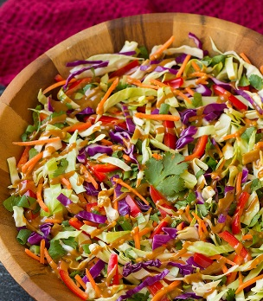
Asian Peanut Cole Slaw

3-4 SERVINGS (1 cup per serving)
Nutrition Facts per Serving:
Calories: 94 Protein (g): 4
Fat (g): 8 Carbohydrate (g): 2

Ingredients:
3 tbsp. | Peanut butter
2 tbsp. | Warm water
3 tbsp. | Rice vinegar
2 tbsp. | Lime juice
1 tbsp. | Fresh ginger, minced
1 ½ tsp. | Sriracha (or other Asian hot sauce)
½ tsp. | Soy sauce (low sodium, preferably)
3 cups | Red cabbage, thinly sliced
3 cups | Green cabbage, thinly sliced
1 | Medium sized carrot, cut into small strips
1/3 cup | Green onions, thinly sliced
 | Optional: red bell pepper slices, chopped peanuts, edamame, chopped cilantro, etc.
Instructions:
- Combine peanut butter, warm water, rice vinegar, lime juice, fresh ginger, Sriracha sauce, and soy sauce in a bowl and mix well until texture is smooth and creamy.
- Combine all other ingredients and toss with peanut sauce.

